**Wild Fires in the United States from 1992-2015: Write-Up**

**SMU Data Analytics Bootcamp | Project 3**

**Group 1: Rob M., Ryan Johnson, Raj Agrawal, Ann Ly**

1. Introduction

“Wildfires are unplanned fires, including lightning-caused fires, unauthorized human-caused fires, and escaped fire from prescribed burn projects.”---Wildfire Statistics(fas.org). According to the National Geographic article on wildfires: "Wildfires: How they form and why they're so dangerous," meteorologists aren't yet able to forecast wildfire outbreaks, but there are three conditions that must be present for a wildfire to burn. Firefighters refer to it as the fire triangle: fuel, oxygen, and a heat source. People cause the majority of the wildfires but add to that dry weather, drought, and strong winds and we will have a perfect disaster recipe for wildfires that can last from weeks to months-long that consumes thousands of acres. Of course, we have to mention another major cause of wildfires in the forest, which is lighting. Scientists have found that every degree of global warming set off a 12 percent bump in lighting activity and since 1975, the number of fires ignited by lighting has increased between two and five percent.

Wildfires have a huge impact on people, our planet, and wildlife. On average, according to estimates, wildfire smoke kills 339,000 people a year, mostly in Asia and sub-Saharan Africa. The number of people increases in asthma attacks, emergency room visits and hospital admissions are up to ten times where active smoke blankets the places where they live. Smoke also contains carbon monoxide, causing long-lasting damage to the heart. According to a NASA study from 2016, boreal forests, which store more carbon than any other terrestrial ecosystem on the planet, can heat the entire planet when it is on fire. Therefore, in those areas, climate changes are playing out twice as much. Now, as for wildlife, wildfire plays a mixed role in this. While some of the animals will die from a wildfire if they do not escape quickly enough, wildfire normally clears out clutters in the forest such as old logs, leaves, and dense undergrowth, restore them to the soil, and makes them more fertile. Wildfires also boost microbial life in the forest floor, and clear out invasive weeds, insects, or diseases. New grassland is sometimes formed after a fire, and that will benefit the wild animals.

1. Data

The dataset that we choose for our project is “US Wildfire data” taken from Kaggle. Our original dataset came in CSV format, with 18455 Kb in size, and has 43 columns. This dataset contains randomly selected 50,000 fire samples from a huge dataset of 1.88 Million US Wildfires ranging from wildfires data from the year 1992 to 2015. Our goal is to analyze the data, then determine if:

* What months or seasonality that have the highest number of wildfires in the US?
* What region of the US that most likely to have more wildfires than others?

We created a web-based dynamic dashboard that displays visual graphs and an interactive map to answer the research questions we came up with using the data we found.

1. Data Cleaning

We used Pandas and Jupyter Notebook to clean the data. First, we identify and drop all of the unneeded columns. Then, we dropped any cells that have null climate data in the column “Temp_pre_30.” After that, we selected the cells with names in the “Fire Name” column and dropped all with null values. Finally, we saved the cleaned version of the "Wildfires" dataset to new CSV and SQLite files. The original dataset is 18455 KB and has 43 columns, but after we cleaned it up, it contains 4883 kb and 23 columns.

1. Visualization & Design

We built our dynamic website dashboard using HTML, JavaScript, and CSS. Our website consists of 4 pages: Home, Plots, About Us, and Resources.

On our Home page, we have a little background about wildfires. We also have hot topics including which state has encountered the most wildfires, the leading cause of wildfires, how many wildfires occur every year, and the number of acres burned on average due to wildfires. If you click on the question, the answer will appear under the question. There is also a "Call to Action" box, which reminds every one of us to do our part when we see a wildfire.

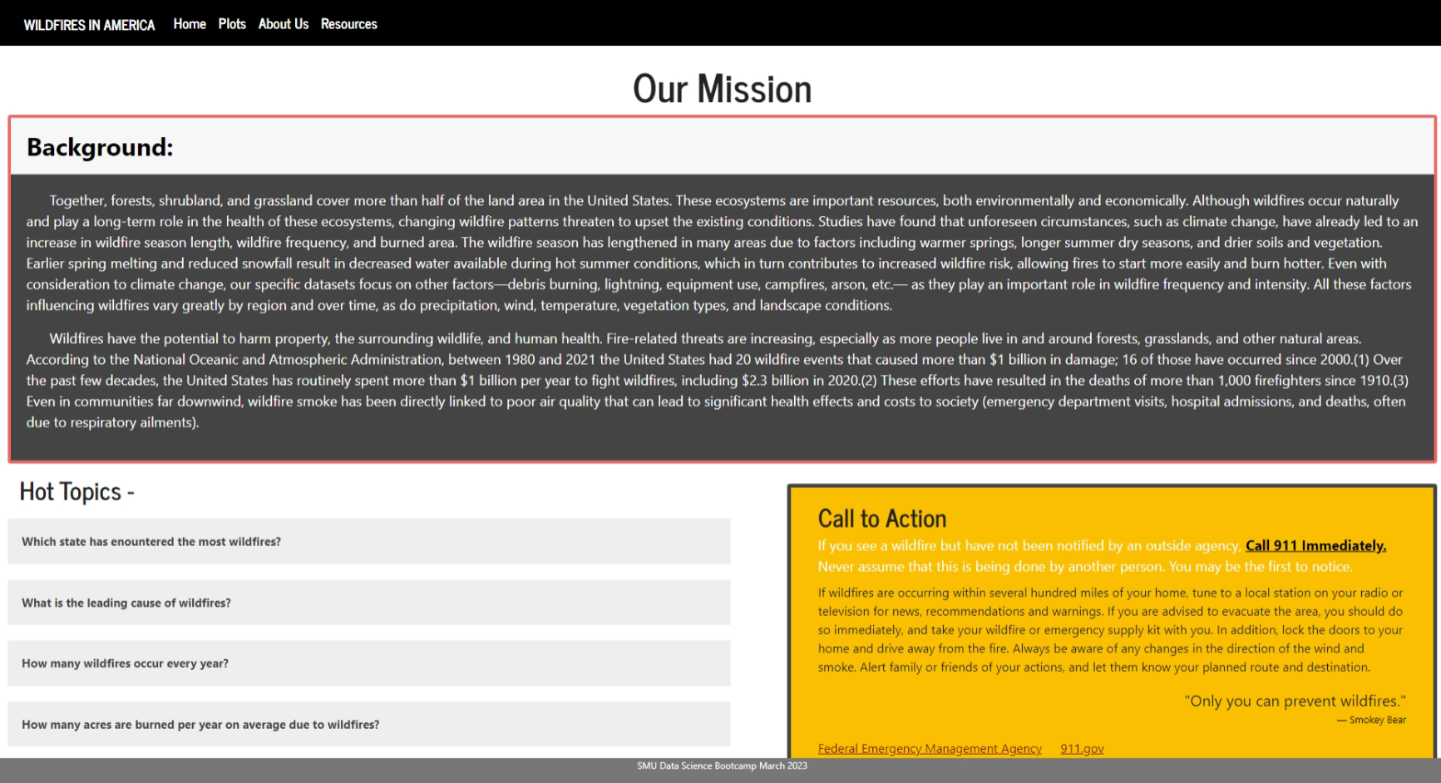

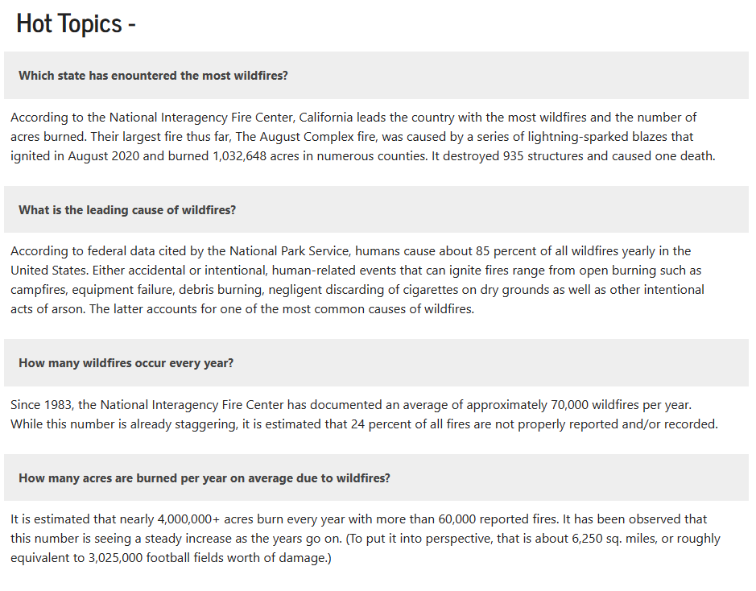

Our second page consists of 2 charts and a map. It has a filter option where you can filter to see the top 10 largest fires in your state and the percentage of wildfires by month in the state that you choose. Our website's map was created using a Leaflet map with a heat filter and marker clusters. The map can be displayed as a "Street Map", "Topographic Map", "Google Satellite", or "Water Color." The markers and heat map can be selected on or off. The colors used on this page are consistent with the color palette that we want to use for this project, warm colors, which are orange, yellow, and red.

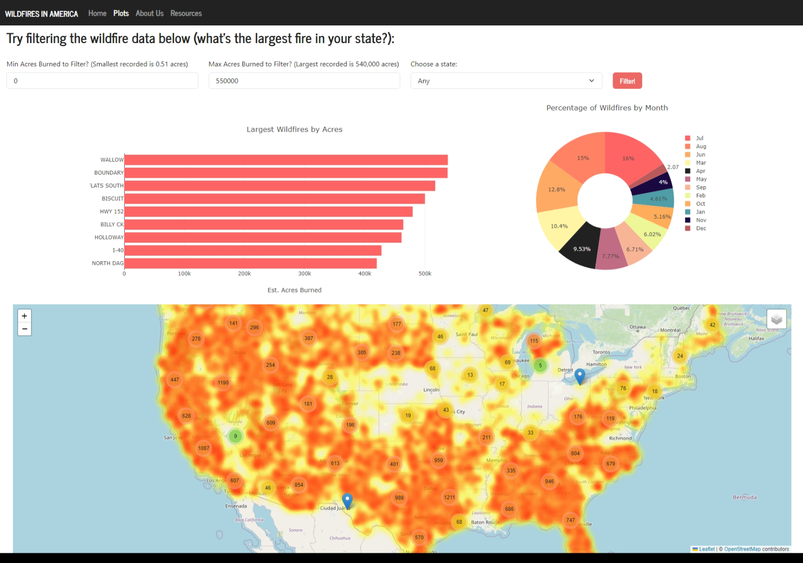

Our third page is “About Us”.



Our last page is our “Resources” page, which listed websites where we got our work cited.

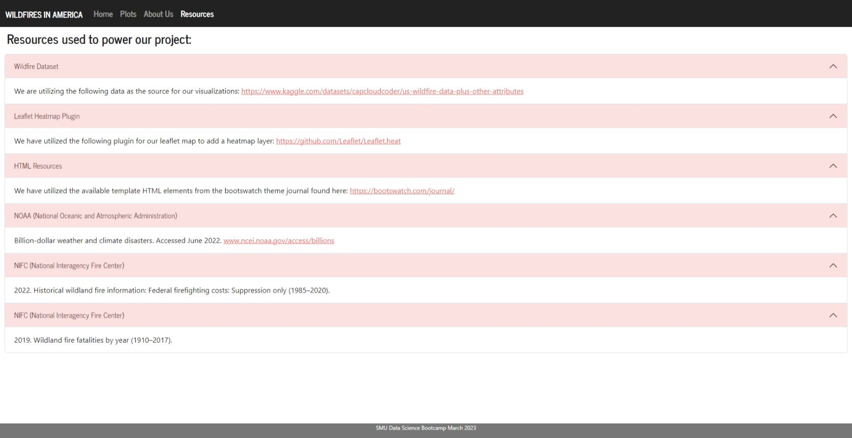

1. Data Analysis

According to our data, these are the top 10 states with the most wildfires from 1992-2015. Notice how the majority of the states are located in the West, East, and Southern parts of the US. TX and CA were the leading states with the most wildfires in that period. Wildfires that resulted in TX, NM, AZ, GA, OK, and CA were most likely due to vegetation, weather condition, and drought.

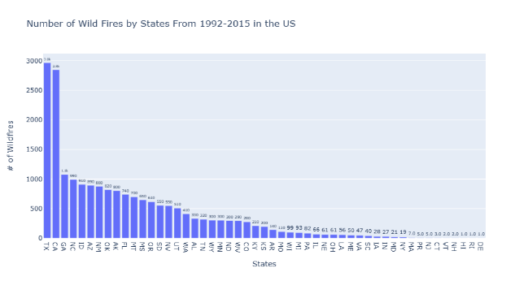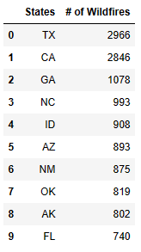

We also break down the months that have the most number of wildfires in the US using pie chart (percentages) and regular bar graph. As predicted, the summer months (July, June, and August) are leading with the number of wildfires.

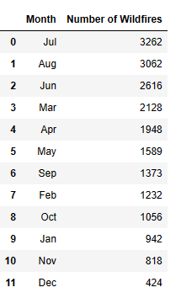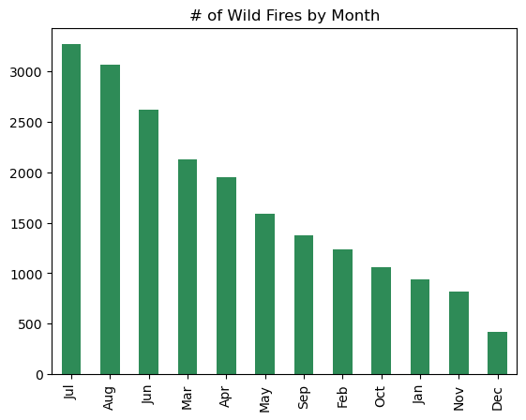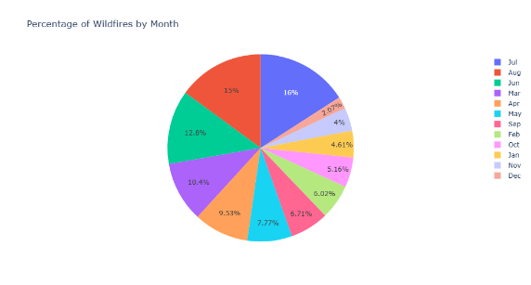

According to the Fire Size Class Code to the right, we can see that the majority of the wildfires affected .26-99.9 acres follow by 100-299 acres, 500-9999 acres, 1000-4999 acres, 100-299 acres, and lastly, class E with 440 wildfires affecting 300-999 acres.

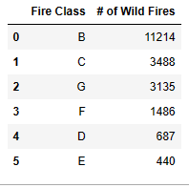 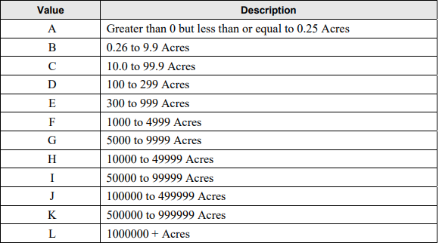

The below table lists the 13 causes of wildfires from our dataset. As expected, lighting is our number one cause, followed by debris burning. We can’t identify the exact causes in the “Miscellaneous”, and “Missing/Undefined” rows, but we can guess that it might be involved humans since most of the studies done on wildfires indicate humans as the number one cause of wildfires.

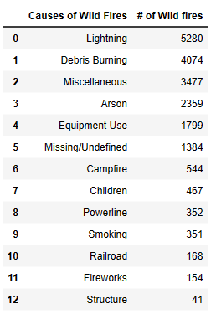

VI Conclusion

In conclusion, most of the states in the South, West, and Southeast of the US have the most wildfires in 1992-2015. These wildfires resulted from weather patterns, drought conditions, and strong winds. Also not to forget about lightning as well since it is the leading cause of wildfires based on our data. We have guessed that the summer months are most favorable for wildfires due to the reasons mentioned above. Our graph validates our guess by listing June, July, and August as the leading months with the most wildfires in the US.

VII Limitations

Our dataset only contains information on wildfires from 1992-2015, and it is only the sample of 50000 wildfires from a bigger dataset of 1.88 Million wildfires. Without data from recent years and the capability to work with a bigger data set, we do not have an accurate picture of the location, seasonality, months, and causes of wildfires in the United States to make better predictions.

VIII Reference Pages

-The benefits of wildfires [﻿The Ecological Benefits of Forest Fires | Eartheasy Guides & Articles](https://learn.eartheasy.com/articles/the-ecological-benefits-of-forest-fires/)﻿​​​﻿﻿﻿

- Wildfire Statistics <https://sgp.fas.org/misc/IF10244.pdf>

-Fire Size Class Code https://www.nwcg.gov.sites/default/files/data-standards/pdf/values.pdf

- [﻿﻿﻿﻿﻿​Wildfires: How They Form, and Why They're so Dangerous (nationalgeographic.org)](https://education.nationalgeographic.org/resource/wildfires-how-they-form-and-why-theyre-so-dangerous/)